Mail to:
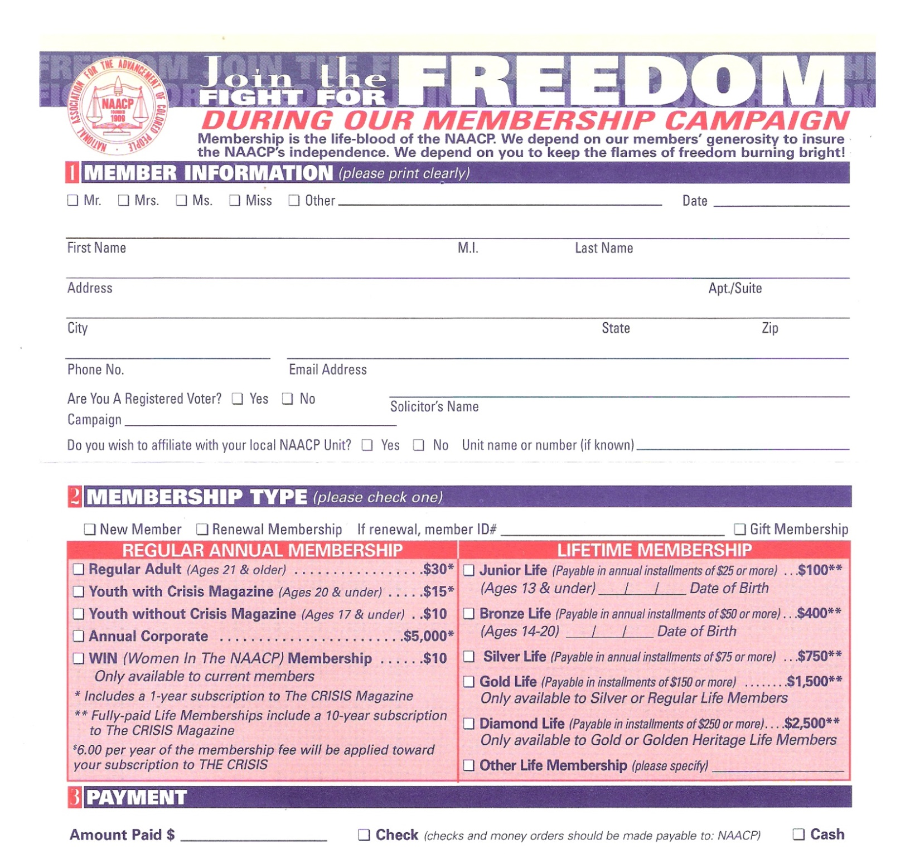
​Pickens County Branch NAACP
Post Office Box 772
Easley, SC 29641
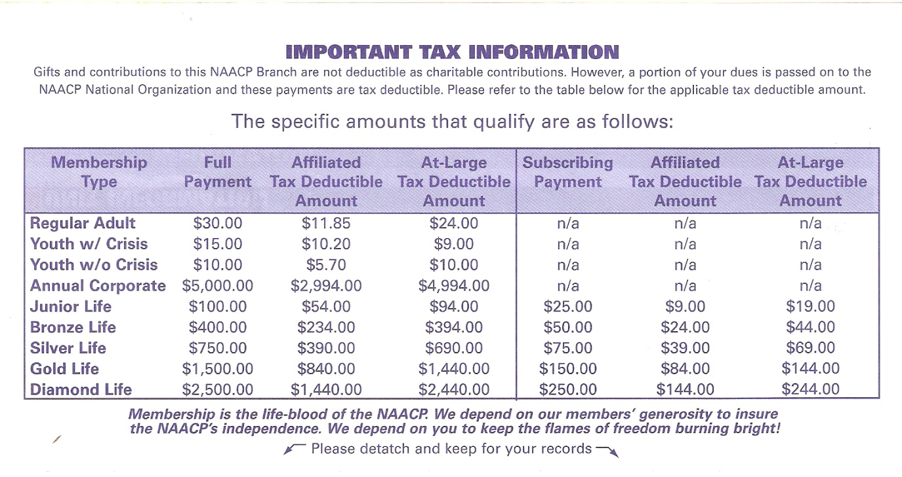
This page is for your own personal records and does not need to be mailed in.

